**Bug 2 Log:  
  
H1** – roomNumber is coming in incorrectly from the UI  
**Test** – Check the values for roomNumber before and after the call to the control class  
**Result** – Hypothesis incorrect: roomNumber is coming in correctly from the UI to the control class

RecordServiceUI line 32  
We can see that there is no roomNumber value before the method call  
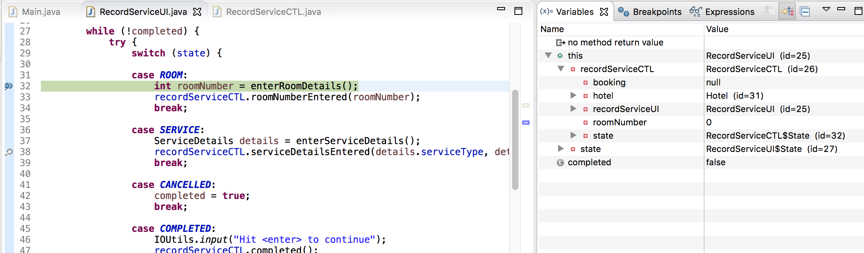  
RecordServiceUI line 33  
After the enterRoomDetails method runs a local variable called roomNumber is correctly assigned 101 from the UI  
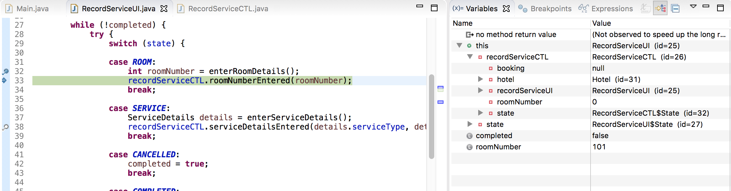  
RecordServiceUI line 34

We can see after the call to the control class method roomNumberEntered that it has correctly assigned this.roomNumber = 101 (sane)  
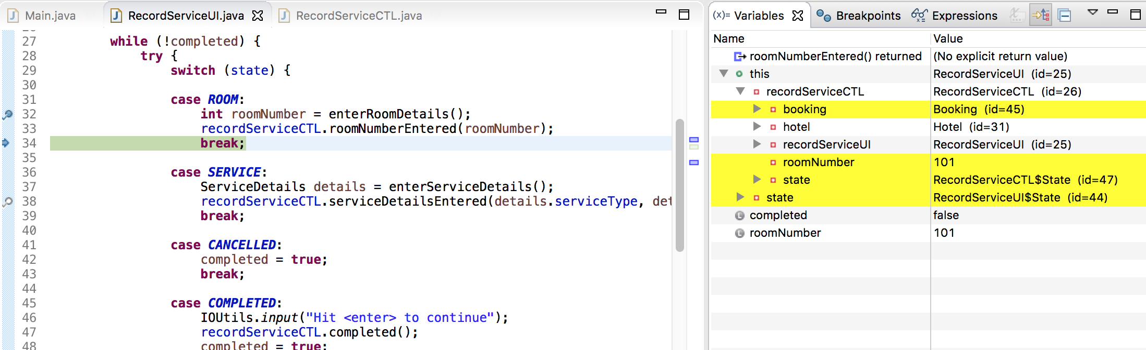

**H2** – The method findActiveBookingByRoomId is returning the wrong booking  
**Test** – Check the booking values before and after the method call to the control class  
**Result** – Hypothesis incorrect: the correct booking is being returned for roomNumber = 101  
  
RecordServiceUI – line 32  
We can see that before the method call to the control class that the booking value is null (sane)  
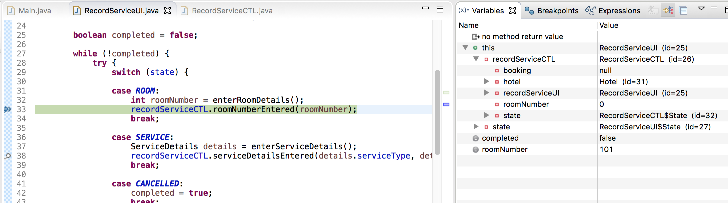

RecordServiceUI – line 33  
We can see that after the method call that the correct booking is retrieved with all the correct variables  


**H3** – The booking is never removed from activeBookingByRoomId  
**Test** – Check values before and after call to method  
**Result** – Hypothesis correct: the booking is never removed from activeBookingByRoomId

CheckoutCTL – line 116  
We can see that before the call to hotel.checkout(roomId) that the booking is still in the activeBookingByRoomId HashMap (sane)  
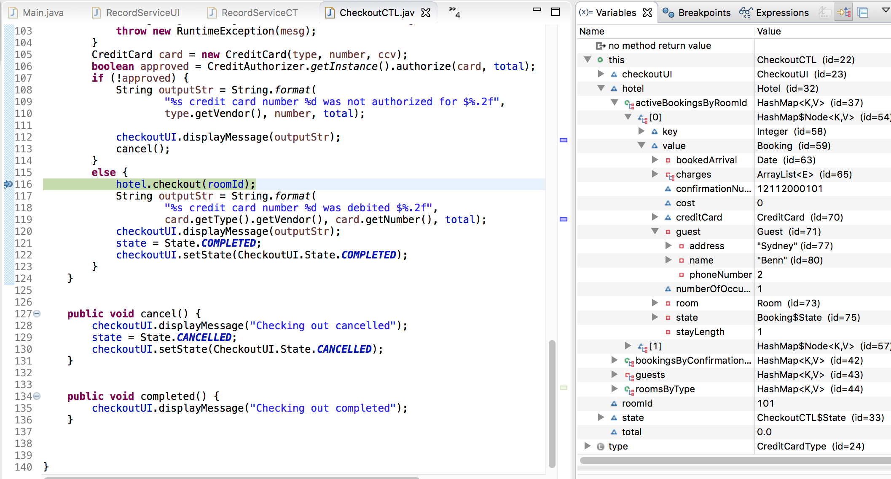

CheckoutCTL – line 118  
After the method call we can see that the booking is still appearing in the activeBookingByRoomId Hash Map (insane)

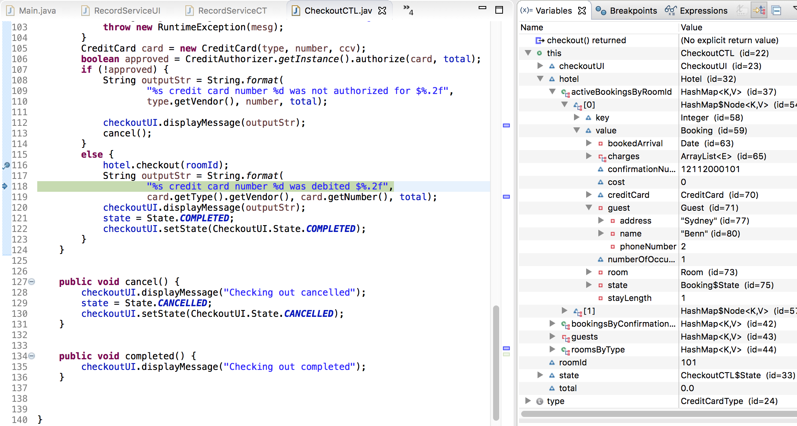

Hotel – line 123  
If we step into the hotel.checkout(roomId) method and step through it we can see that the booking is never removed  
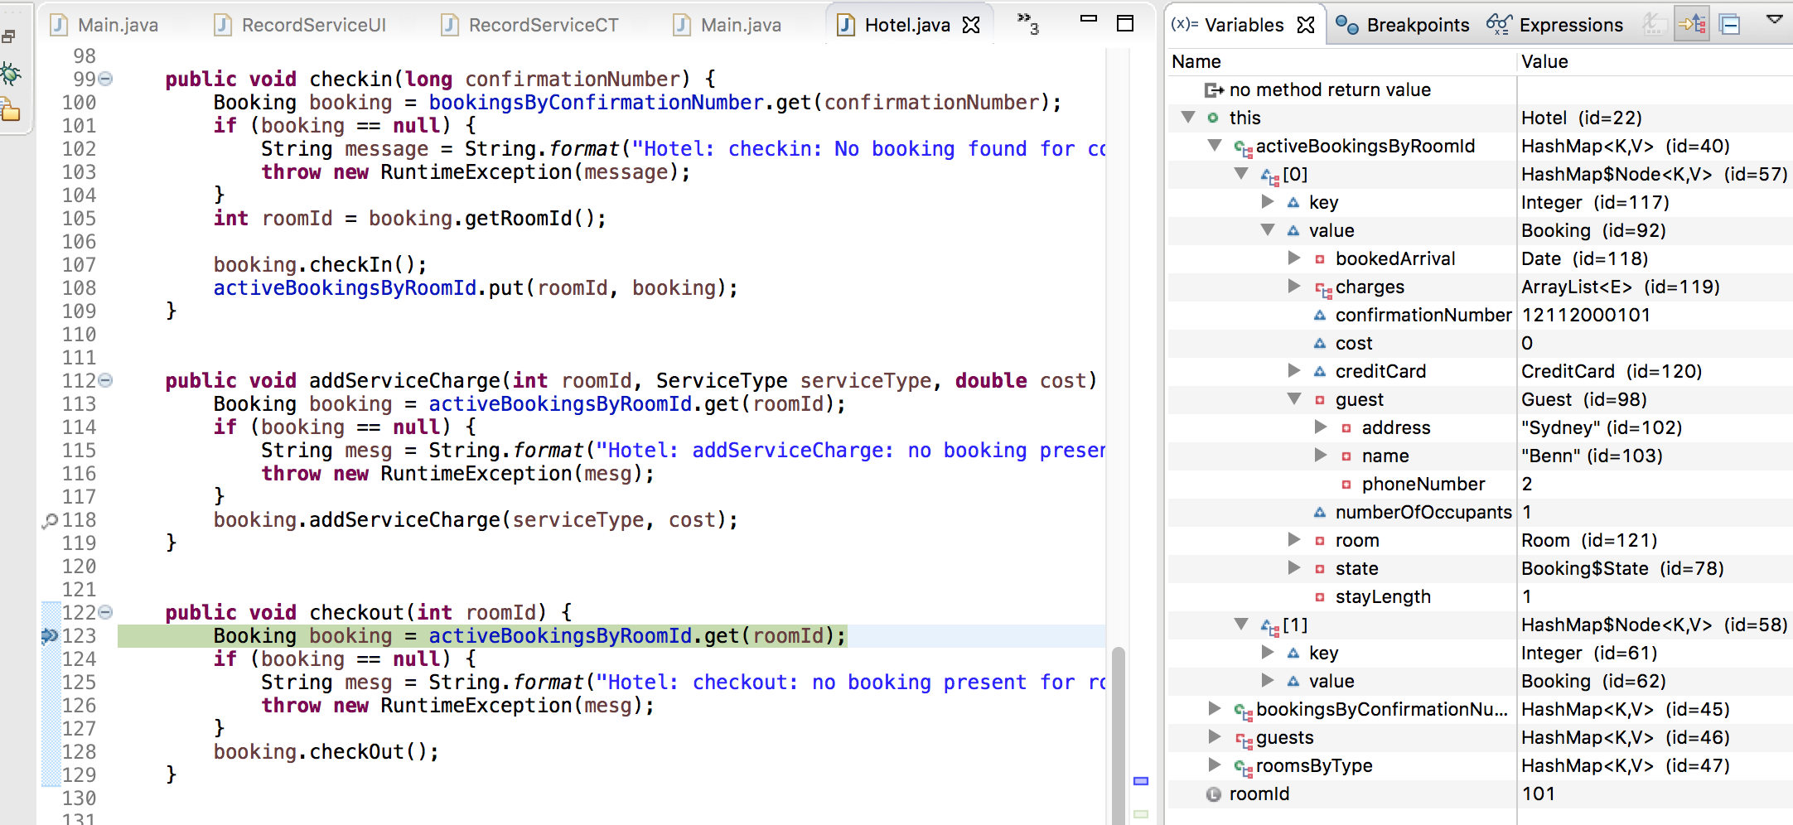

Hotel – line 123  
get() returns the booking

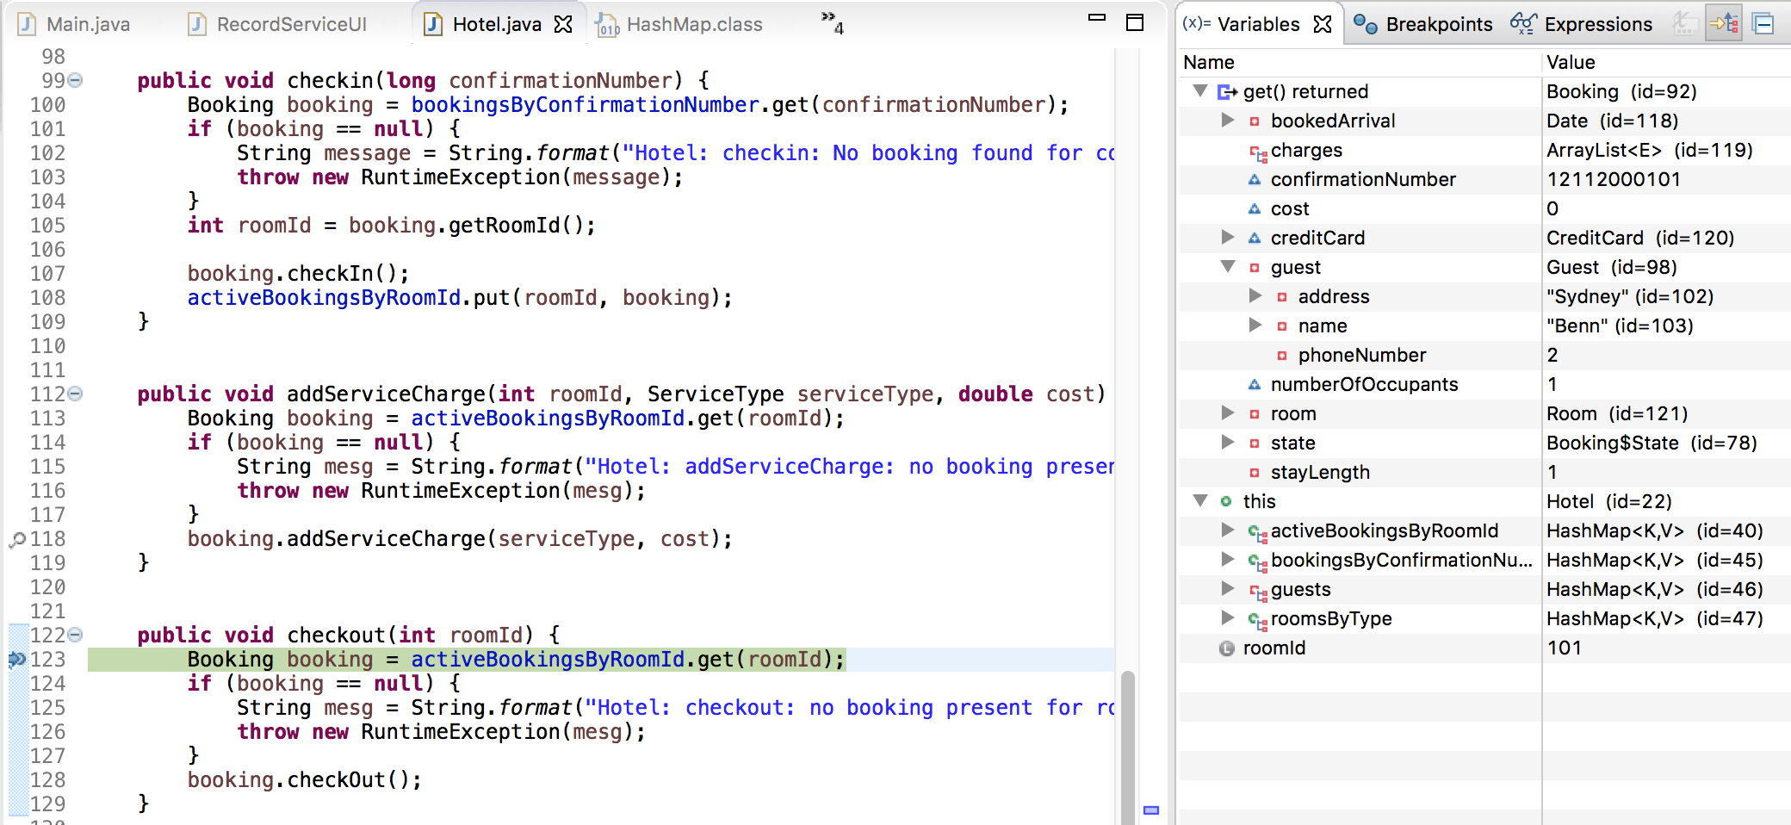

Hotel – line 128  
We can see that the booking is still active and has been assigned to the local booking variable  
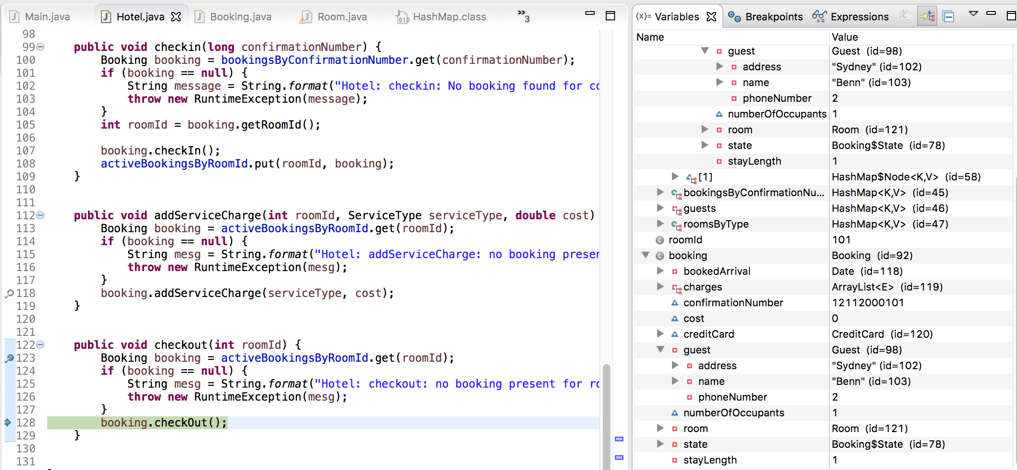

Hotel – line 128  
activeBookingByRoomId

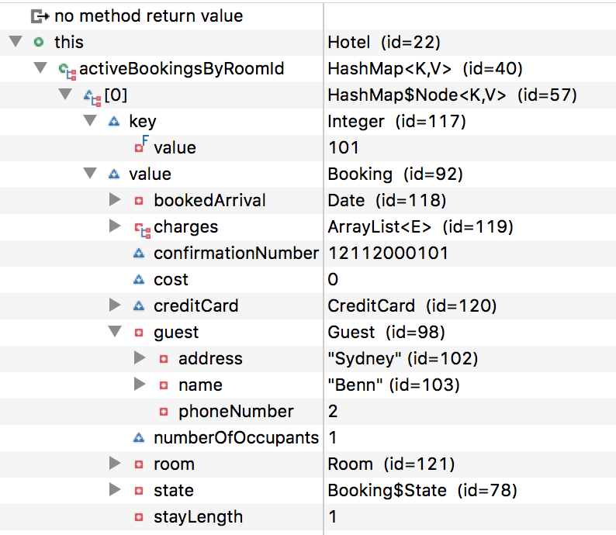

Hotel – line 128  
local booking variable  
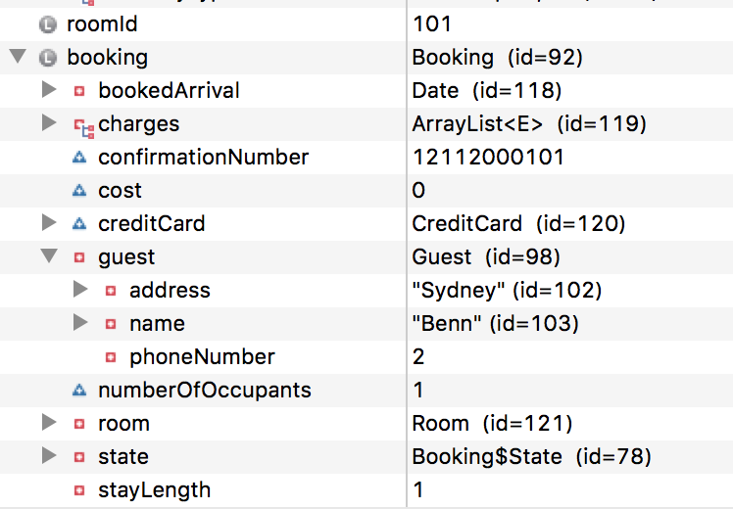  
  
Booking – line 147  
Stepping into the booking.checkout()  
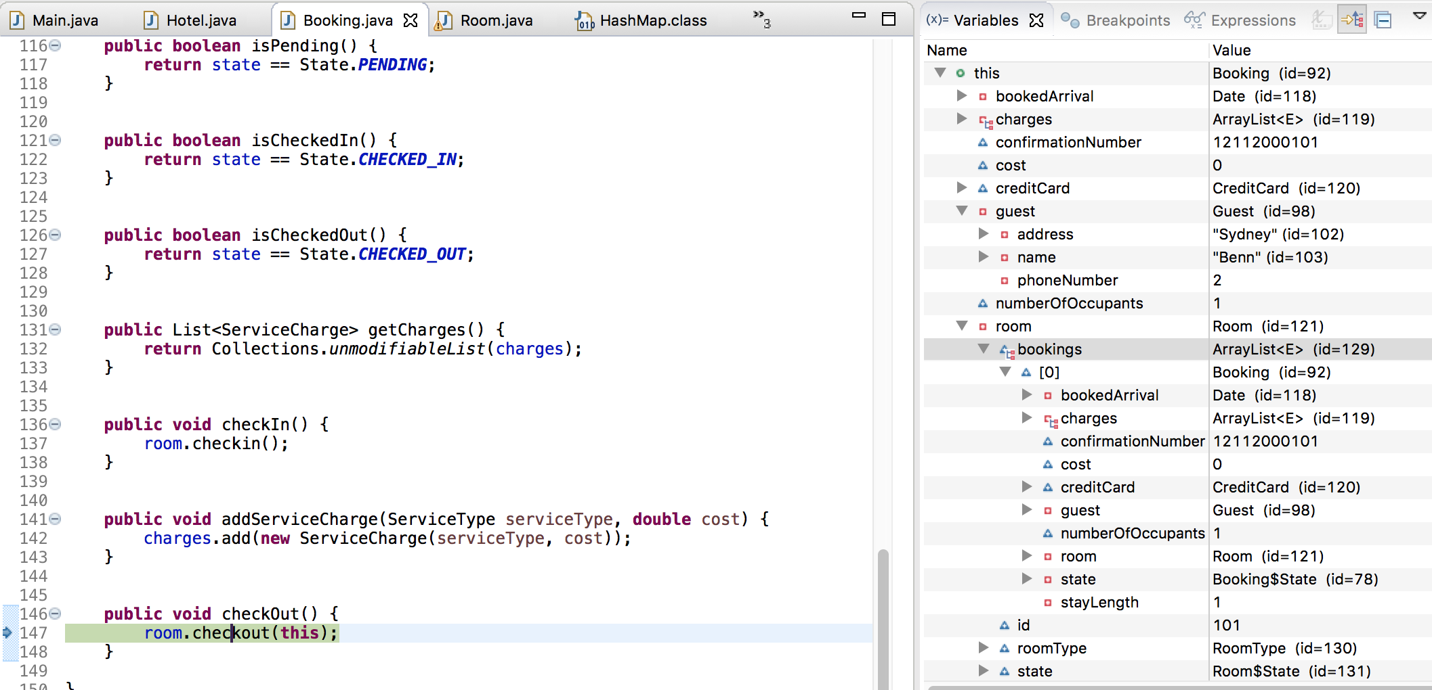

Room – line 75  
Stepping into the room.checkout()  
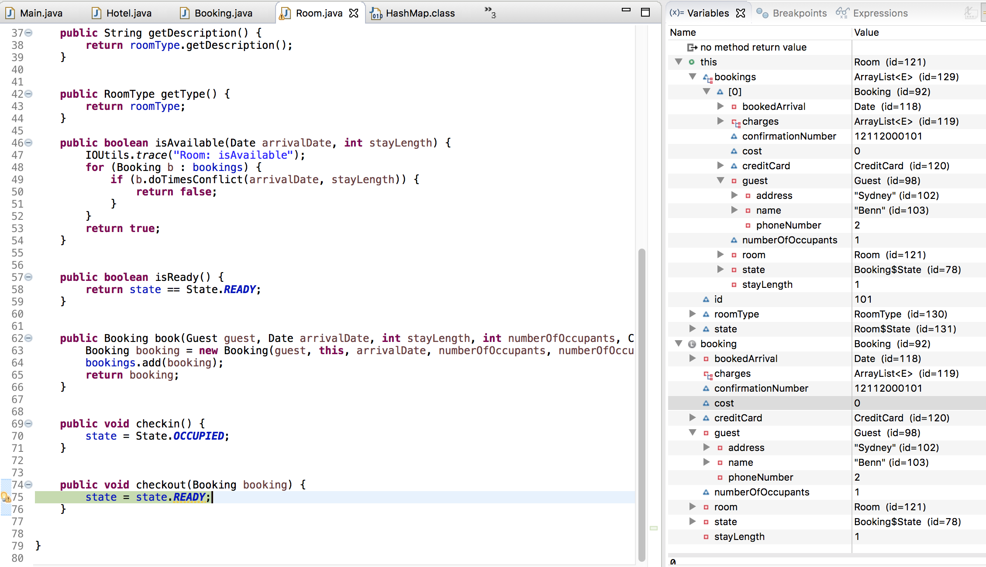

Room – line 76  
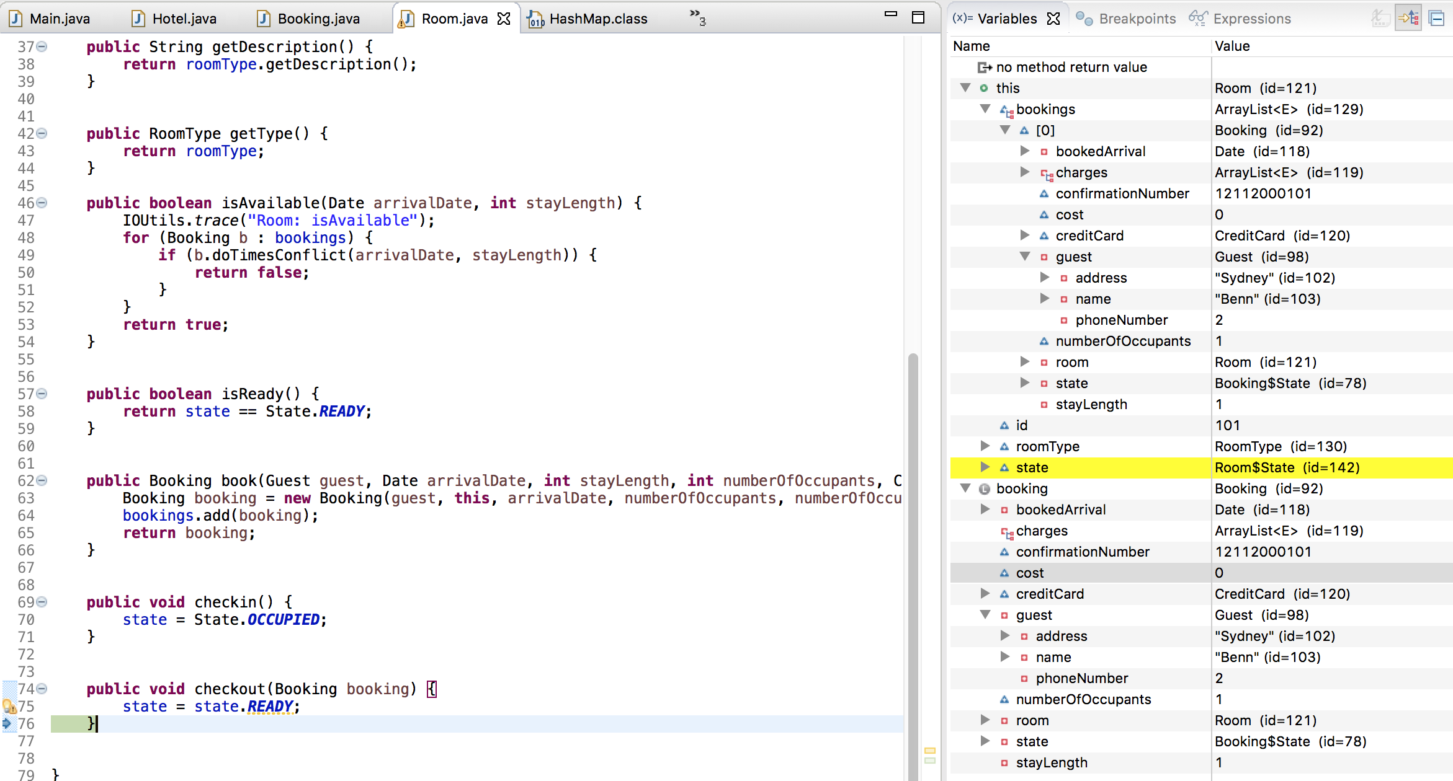

Booking – line 148

Stepping back through as each method returns  
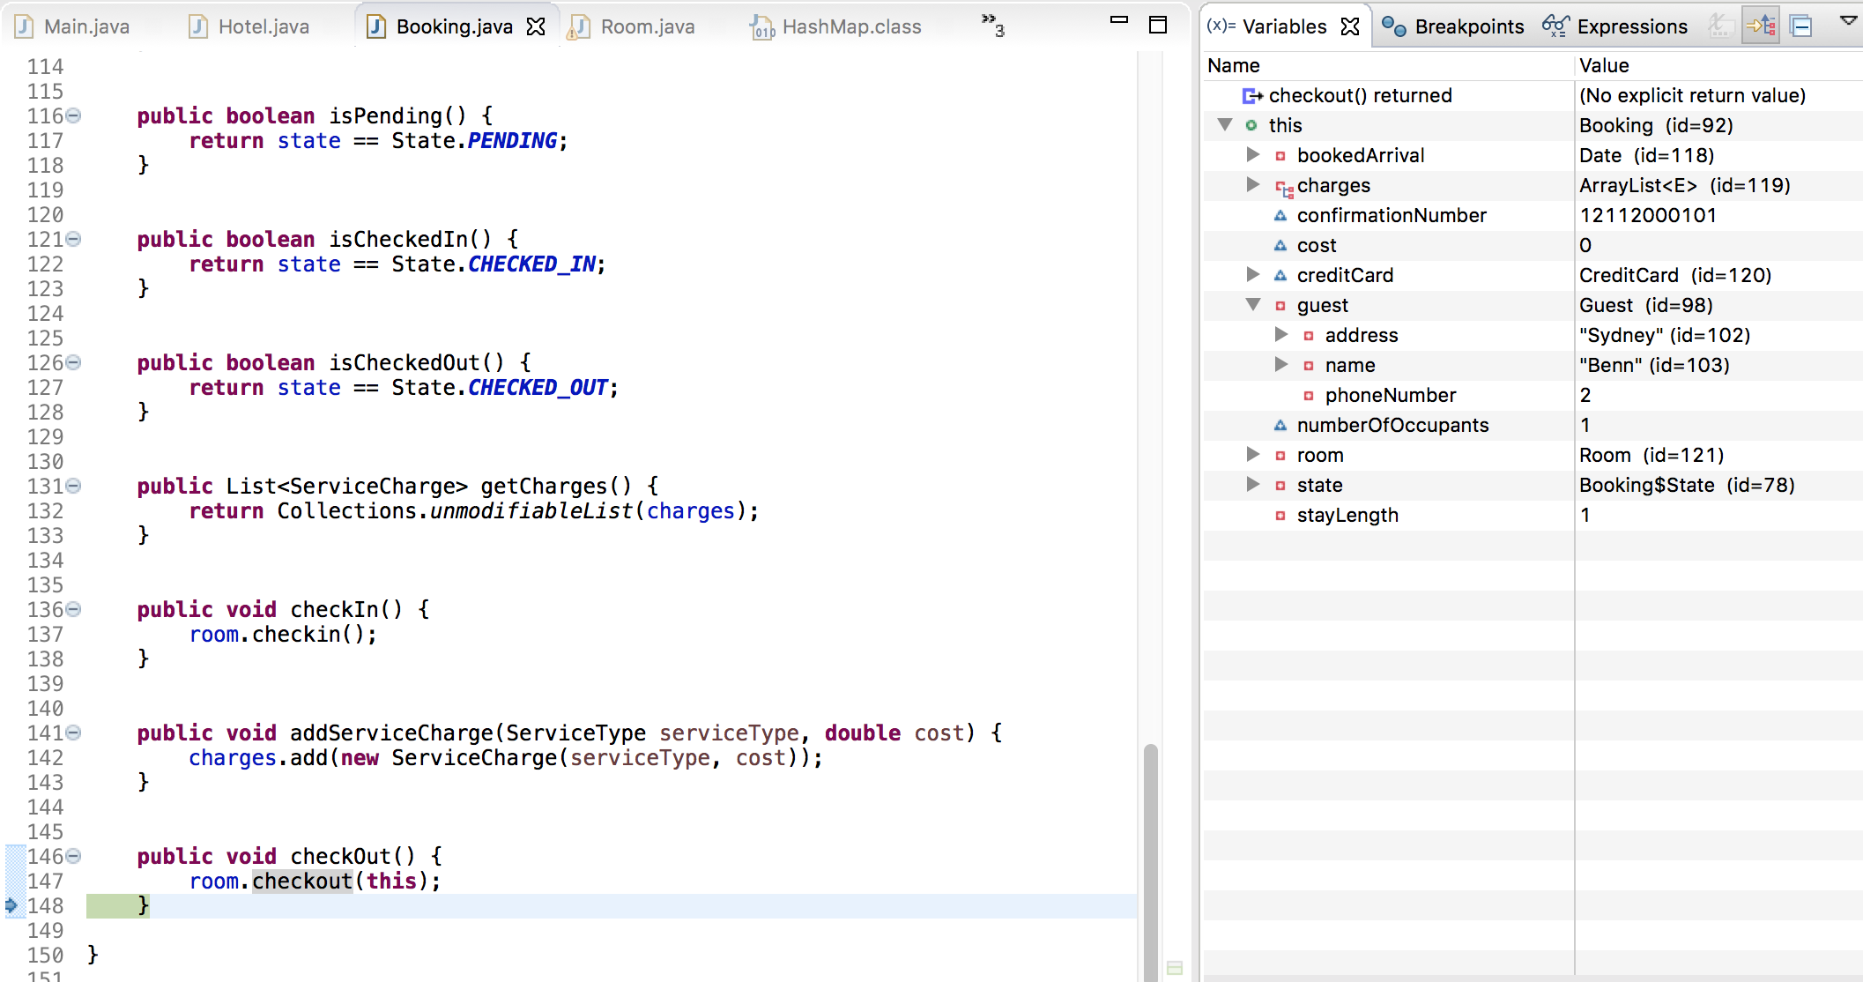  
Hotel – line 129  
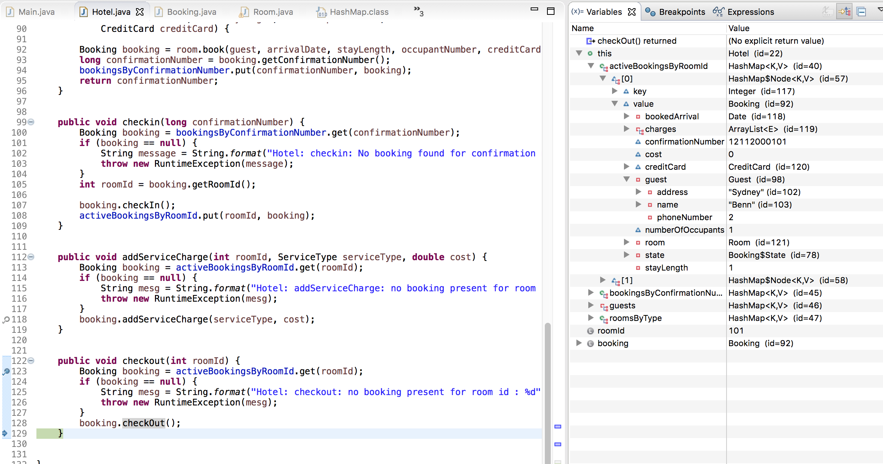

Hotel – line 129  
local booking variable values  
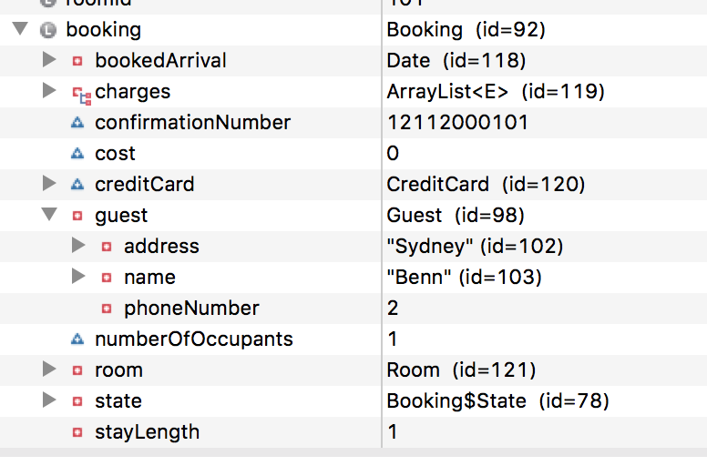

CheckoutCTL – line 118  
We have stepped through the entire checkout() but the booking still remains in the activeBookingByRoomId HashMap  
